Real-Time Anomaly Detection in IoT Sensor Data via Deep Learning and Deployment with Python Frameworks
Abstract
The project presents a comprehensive real-time anomaly detection system for Internet of Things (IoT) sensor data using deep learning. The solution leverages Long Short-Term Memory (LSTM) neural networks to identify unusual patterns or deviations in multivariate time-series data collected from various IoT devices such as temperature, humidity, air quality, light, and loudness sensors. The model is trained on historical sensor data and deployed using an interactive and visually appealing Streamlit-based web application. The system preprocesses uploaded CSV files, normalizes the input using a MinMaxScaler, and creates time-series sequences that are then passed to the trained LSTM model. The web interface supports real-time visualization, including anomaly-tagged time series, reconstruction error distribution plots, and detailed data summaries. It offers a user-friendly experience with clear instructions, customizable visualizations, and downloadable CSV results for post-analysis. This end-to-end solution demonstrates how deep learning can be effectively applied to the domain of IoT for anomaly detection, addressing practical challenges in monitoring, alerting, and maintaining data-driven infrastructures in smart environments.
Keywords: Anomaly Detection, Time Series Forecasting, LSTM Neural Networks, Sequence Modeling, Streamlit Web App, Sensor Data Analytics, Real-time Monitoring, Deep Learning, Reconstruction Error, Data Visualization, Predictive Maintenance, Edge AI, Smart Environments.

CHAPTER I
INTRODUCTION

1.1 Objective of the Project
The advent of the Internet of Things (IoT) has brought about a paradigm shift in how data is collected, processed, and interpreted. From smart homes and wearable devices to industrial automation and smart agriculture, IoT devices are embedded in virtually every aspect of modern life. These devices continuously gather time-stamped sensor data that reflects physical conditions such as temperature, humidity, pressure, air quality, and sound levels. Monitoring this data for irregularities or anomalies is vital for maintaining system reliability, detecting security breaches, preventing equipment failures, and optimizing operational efficiency.
However, detecting anomalies in time-series data from IoT devices is a complex task due to the high dimensionality, temporal dependencies, and the presence of non-stationary patterns. Traditional rule-based or statistical approaches fail to capture the intricate relationships between variables or adapt to evolving data distributions.
This project aims to bridge that gap by developing a robust, deep learning-based system using Long Short-Term Memory (LSTM) neural networks. LSTM Autoencoders are particularly suited for capturing long-term dependencies in sequential data and reconstructing input sequences. By learning from normal behavior patterns, the model can effectively flag deviations that represent anomalies. Furthermore, the project includes the creation of a modern, interactive web application using Streamlit, empowering end-users to utilize the system without any deep technical knowledge.

The primary objectives of the project include:
- Designing and training an LSTM Autoencoder model for unsupervised anomaly detection on multivariate time-series sensor data.
- Providing a user-friendly interface to upload IoT datasets, conduct real-time analysis, and view results interactively.
- Implementing advanced visualization techniques to clearly communicate detected anomalies.
- Exporting results in a standardized format for further investigation or integration with downstream analytics pipelines.
- Supporting scalability and modularity to accommodate a wide range of IoT applications.

1.2 Software and Hardware Requirements

Software Requirements:
To build and deploy the anomaly detection system, the following software stack is used:
Software Component | Description
Python 3.9+ | Core language for development
TensorFlow 2.11+ | Deep learning framework for building LSTM models
Keras | High-level neural network API running on top of TensorFlow
Pandas | Data manipulation and analysis library
NumPy | Fundamental package for numerical computation in Python
Scikit-learn | Machine learning tools for data preprocessing and evaluation
Streamlit | Framework for creating interactive data apps
Plotly | Visualization library for interactive plots
Matplotlib & Seaborn | For static visualizations and exploratory data analysis
Jupyter Notebook / Colab | Development environment for experiments and model training

Hardware Requirements:
The system is designed to run efficiently on moderately equipped machines. However, enhanced performance is observed with higher hardware configurations.

Hardware Component | Minimum Specification | Recommended Specification
Processor (CPU) | Intel Core i5 or equivalent | Intel Core i7 or AMD Ryzen 7
RAM | 8 GB | 16 GB or more
GPU (for training) | Optional | NVIDIA GPU with CUDA support
Storage | 10 GB free space | 50 GB SSD
Operating System | Windows/Linux/macOS | Ubuntu 20.04 LTS or Windows 11

1.3 Modules Description
The system architecture is composed of several interconnected modules, each handling a specific task in the data analysis and anomaly detection pipeline. A modular approach ensures flexibility, scalability, and ease of maintenance.

1.3.1 Data Acquisition and Preprocessing Module
This module is responsible for ingesting data from IoT sensors in CSV format. It handles time conversion, missing values, and normalizes the features using Min-Max scaling. This normalization ensures that all sensor readings are on a comparable scale, which improves the performance of the LSTM model.

1.3.2 Sequence Generator Module
Since LSTM networks operate on sequential data, this module transforms the continuous sensor data into overlapping sequences using a sliding window approach. Each sequence captures temporal dependencies across multiple sensor readings.

1.3.3 Model Training Module
In this module, an LSTM Autoencoder model is trained on a dataset containing only "normal" behavior. The model architecture consists of an encoder that compresses the input sequences into a latent representation, and a decoder that attempts to reconstruct the original sequence. The training objective is to minimize the mean squared error between the input and reconstructed output.

1.3.4 Anomaly Detection Module
After the model is trained, new incoming data sequences are passed through the autoencoder. Reconstruction error is computed for each sequence. Sequences with error exceeding a defined threshold (e.g., 95th percentile of training error) are flagged as anomalies. This unsupervised technique does not require labeled data.

1.3.5 Streamlit Web Interface Module
This module provides the graphical user interface of the system. Built using Streamlit, it allows users to upload CSV files, view data previews, configure options, trigger anomaly detection, and explore results. The interface includes a dynamic dashboard with real-time feedback.

1.3.6 Visualization and Reporting Module
The system uses Plotly to generate interactive time-series plots highlighting detected anomalies. A histogram of reconstruction errors helps users understand the thresholding mechanism. An option to download the analysis results in CSV format ensures integration with external systems.

1.3.7 Model Deployment and Integration Module
The trained model is saved in .keras format and loaded during application startup. This ensures rapid inference on new data. The module also ensures compatibility with future real-time data streams, allowing integration with MQTT or REST APIs.
In summary, the system's modular design, deep learning core, and interactive frontend make it a comprehensive solution for anomaly detection in IoT sensor data. Each module plays a critical role in ensuring the system is both accurate and user-friendly.

CHAPTER II
LITERATURE REVIEW

[1] Zaman et al. present a comprehensive review of IoT technologies as foundational elements for the development and effective management of smart cities. Their work spans a wide spectrum of IoT applications including infrastructure, traffic control, environmental monitoring, and public safety. The authors also explore architectural frameworks and integration strategies that enhance interoperability and scalability in urban environments. From a customer segmentation standpoint, this paper highlights how IoT-generated data can inform resident behavior profiling and enable services tailored to population clusters, thereby contributing indirectly to e-commerce and service personalization. The review outlines challenges such as data privacy, energy efficiency, and real-time analytics, all of which are critical in designing secure and efficient smart city ecosystems. Importantly, it sets the stage for understanding how IoT analytics can blend with machine learning techniques to enable intelligent segmentation in domains ranging from utilities to transport.
[2] This research investigates a dual-architecture approach to anomaly detection in smart city IoT networks using Federated Learning (FL) and Split Learning (SL). Priyadarshini’s work contributes significantly to privacy-preserving model training by ensuring that sensitive IoT data remains decentralized. The anomaly detection models are collaboratively trained across multiple nodes without data exchange, which is crucial for security and compliance in smart city environments. These techniques help in identifying suspicious behaviors in real-time traffic, surveillance systems, and critical infrastructure devices. The model's ability to identify outlier patterns can be translated to customer segmentation use cases, where decentralized behavioral insights from edge devices help build accurate, real-time user profiles. The paper also outlines performance benchmarks and scalability considerations, making it valuable for designing robust IoT security frameworks.
[3] This study introduces a hybrid deep learning model that combines Convolutional Neural Networks (CNN), Artificial Neural Networks (ANN), Long Short-Term Memory (LSTM), and Gated Recurrent Units (GRU) for enhancing Intrusion Detection Systems (IDS) in IoT networks. The authors focus on detecting sophisticated and multi-stage cyberattacks in smart city infrastructures. The hybrid approach leverages spatial and temporal feature extraction, making it suitable for real-time and context-aware detection tasks. The study shows how each component of the model contributes to high detection accuracy, reduced false positives, and adaptability to dynamic environments. Although the focus is on cybersecurity, the model's methodology has implications for customer segmentation, where similar architectures can be used to analyze user behavior patterns in streaming IoT data. The approach demonstrates the power of combining multiple deep learning paradigms to address complex, evolving data environments.
[4] Gupta et al. developed a hybrid neural network model combining CNN and GRU to detect network traffic attacks in IoT-enabled smart cities. The model capitalizes on CNN’s spatial pattern recognition and GRU’s temporal sequence learning capabilities. The paper presents rigorous evaluations using benchmark datasets, showing significant improvements in detection accuracy and computation time. From a segmentation perspective, this hybrid architecture is adaptable for clustering user activity into normal and anomalous behavior groups. Such a methodology could be used in smart retail or urban analytics to classify and personalize services based on user traffic and behavior patterns. The paper contributes to the growing body of work where AI-driven solutions are essential in securing and managing smart infrastructure.
[5] This paper surveys the latest research in machine learning (ML) and deep learning (DL) techniques for anomaly detection in IoT networks. Rafique and colleagues provide an extensive classification of supervised, unsupervised, and reinforcement learning methods used in detecting cyber threats, faulty devices, and behavioural anomalies. The review includes comparative performance analyses, challenges in deployment, and future directions such as edge intelligence and federated frameworks. The insights provided are invaluable for building intelligent segmentation models in smart city applications, where understanding device and user behaviours is critical. The study also emphasizes the importance of real-time, lightweight models suitable for constrained IoT devices. The findings contribute to the development of secure, data-driven customer interaction models and automated service delivery mechanisms in connected environments.
[6] This work presents a detailed study of anomaly detection in IoT sensor networks, specifically within the context of autonomous robotic systems and smart city infrastructures. Mantegazza et al. provide a compendium of benchmark datasets and evaluation metrics used to test anomaly detection algorithms. By categorizing anomalies into environmental, behavioral, and systemic, they offer a structured view of how data irregularities can signal emerging hazards. Although the focus is robotics, the underlying principles apply to smart cities and customer segmentation as well, where similar sensors monitor usage patterns, service requests, and mobility data. These benchmarks serve as a foundation for testing segmentation models designed to classify user behavior into normal and abnormal clusters. Their work supports the importance of standardized datasets in training machine learning models for both safety-critical applications and commercial analytics.
[7] Bustamante et al. propose a dual-model anomaly detection framework capable of handling non-linear streaming data typically found in smart city applications. Their system integrates rule-based statistical models with deep learning architectures, effectively balancing real-time performance and learning flexibility. This hybrid approach enables the identification of both known and novel anomalies in dynamic environments, such as traffic systems, public utilities, and surveillance. Their research provides a blueprint for constructing adaptive systems that evolve with changing patterns in user behavior. The methodology is directly relevant to customer segmentation in streaming environments, where behavioral drift or sudden changes may signal churn risk, preference shifts, or fraudulent activity. Their work also underlines the value of fusing domain knowledge with data-driven models for high-fidelity anomaly detection.
[8] This paper explores the integration of artificial intelligence (AI) with blockchain technology to enhance data security and transparency in IoT ecosystems, specifically within smart cities. Khan and co-authors argue that AI models for data classification, segmentation, and anomaly detection can be made more trustworthy and tamper-proof through blockchain’s decentralized ledger. They propose an architecture where AI performs real-time behavioral analytics and the blockchain component ensures data integrity and auditability. The model addresses key challenges in privacy, trust, and access control in multi-entity environments. While the core focus is on data security, the integration of segmentation logic into this secure framework has far-reaching applications in personalized urban services and fraud detection. This study reinforces the importance of combining multiple technologies to overcome limitations in isolated systems.
[9] Ferreira et al. provide a detailed tutorial and comparative study on forecasting network traffic, a key component in managing smart city and e-commerce infrastructures. The paper evaluates traditional statistical models (e.g., ARIMA, Holt-Winters) alongside modern machine learning and deep learning approaches such as RNNs and attention mechanisms. Their open-source benchmarking approach allows researchers to replicate and compare results across datasets and metrics. Accurate traffic forecasting is essential for predicting customer load, resource allocation, and behavioral pattern segmentation. The authors emphasize the importance of explainable models and real-time adaptability in high-throughput environments. Their contribution lies not only in the survey itself but also in providing a replicable testing framework that enhances transparency and innovation in traffic-based behavior segmentation research.
[10] This study introduces an AI-based dynamic traffic light control system designed to alleviate congestion in metropolitan environments. The algorithm leverages real-time vehicle flow data to adjust signal timings dynamically, improving traffic throughput and reducing idle times. Kumar et al. utilize computer vision and machine learning models to classify and predict traffic densities at intersections. While primarily focused on traffic optimization, the underlying methodology of real-time, data-driven adaptation can be extended to customer segmentation in mobility services and urban planning.
CHAPTER III
EXISTING SYSTEM

3.1 Overview of Existing Systems
Anomaly detection in IoT sensor networks has traditionally relied on simplistic rule-based or threshold-based techniques. These systems are configured with predefined upper and lower limits for sensor values. When a reading falls outside this range, it is flagged as anomalous. While this approach is straightforward and computationally inexpensive, it fails to capture the complex relationships and dependencies in multivariate and temporal data.
Moreover, many existing systems are rigid and do not adapt to changes in operational behavior or environment. This results in high false-positive or false-negative rates, especially when the system encounters new types of anomalies or previously unseen data patterns. These limitations make traditional systems unsuitable for dynamic, real-world IoT deployments where data variability is high and behavior patterns evolve over time.

3.2 Features of Traditional Systems
- Static Rule Configuration: Requires manual definition of acceptable value ranges.
- Limited Scalability: Difficult to manage rules for a large number of sensors or complex systems.
- Lack of Learning Capability: Cannot learn from historical data or improve over time.
- Univariate Focus: Often considers one sensor at a time, ignoring cross-sensor correlations.
- No Visualization or Feedback Loop: Provides limited insight into the nature or root cause of anomalies.

3.3 Challenges in Traditional Anomaly Detection
- Sensitivity to Noise: Minor fluctuations in data may be flagged as anomalies.
- Concept Drift: Fixed thresholds become obsolete as the system behavior changes.
- False Alarms: Frequent false positives reduce trust in the detection system.
- Low Generalizability: Rules that work for one deployment may not transfer to another.
- Manual Intervention Required: System tuning and maintenance require domain experts.

3.4 Limitations Highlighted by Use Cases
In industrial use cases such as predictive maintenance, environment monitoring, and smart energy systems, the limitations of existing rule-based systems become apparent. For instance, a fixed threshold for temperature might flag legitimate increases due to seasonal changes as anomalies. Similarly, missing context on multivariate dependencies (e.g., humidity affecting temperature sensors) leads to misinterpretations.
In response to these limitations, modern approaches leverage machine learning and deep learning to develop adaptive, data-driven anomaly detection systems. These models learn from historical trends, adapt to changing conditions, and provide richer insights through interpretability and visualization — forming the foundation for the proposed system described in the next chapter.

CHAPTER IV
PROPOSED SYSTEM
4.1 Overview
The proposed system is a deep learning-based anomaly detection framework tailored for IoT sensor networks. Unlike static, rule-based approaches, our system leverages Long Short-Term Memory (LSTM) Autoencoders to model temporal dependencies and detect irregularities in time-series data. This approach is capable of handling multivariate input, adapting to complex data distributions, and generalizing well to unseen scenarios.
This system is implemented as a complete end-to-end pipeline that includes:
- Preprocessing of raw sensor data (cleaning, normalization, time-indexing).
- Transformation into time-series sequences.
- Unsupervised model training using LSTM Autoencoder architecture.
- Real-time anomaly detection and visualization using an intuitive Streamlit interface.
- Exportable analysis for integration into other platforms.
The design prioritizes modularity, scalability, and user accessibility, making it ideal for a wide range of IoT applications such as smart agriculture, industrial automation, and healthcare monitoring.

4.2 Architecture Diagram
The architecture of the system consists of the following layers:
- Input Layer: Accepts multivariate time-series data in CSV format.
- Preprocessing Layer: Cleans, normalizes, and sequences the data.
- Model Layer: Processes sequences through an LSTM Autoencoder.
- Inference Layer: Calculates reconstruction error and flags anomalies.
- Visualization Layer: Displays results using time-series and histogram plots.
- Export Layer: Allows CSV download of labeled results.

4.3 UML Diagrams
Use Case Diagram:
Actors: User, System Use Cases: Upload Data, View Visualization, Detect Anomalies, Download Report
Activity Diagram:
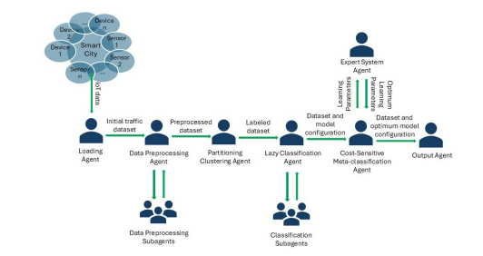
Figure 1: Multi-Agent System Architecture for Smart City IoT Data Processing
Description:
This diagram illustrates a multi-agent framework designed to process and analyze IoT sensor data in smart city environments. The system begins with data collection from various IoT-enabled devices (Device 1 to Device n), each equipped with sensors monitoring urban conditions such as traffic flow, environmental quality, and public infrastructure.
- Loading Agent: Acts as the entry point for the system, importing raw sensor traffic data from the smart city network.
- Data Preprocessing Agent: Cleans, normalizes, and formats the raw data into a structured form suitable for analysis. This process is distributed to multiple subagents to enhance scalability and speed.
- Partitioning and Clustering Agent: Segments the data based on similarity and relevance, preparing it for classification. Labeled datasets are generated here.
- Lazy Classification Agent: Applies initial classification algorithms using lazy learning principles (e.g., k-NN), supported by multiple classification subagents for parallel processing.
- Expert System Agent: Oversees the model training by fine-tuning learning parameters.
- Cost-Sensitive Meta-Classification Agent: Introduces a layer of intelligent learning that balances classification accuracy with cost factors, optimizing for real-world deployment.
- Output Agent: Generates the final results, including anomaly labels and predictions, ready for use in applications like alerting systems or dashboards.
This architecture emphasizes modularity, distributed processing, and expert knowledge integration, making it ideal for dynamic and large-scale IoT environments in smart cities.

Class Diagram:

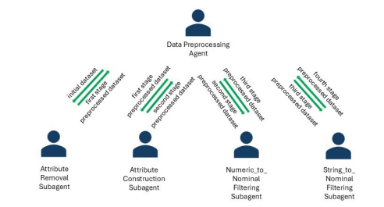
Figure 2: Hierarchical Data Preprocessing Workflow Using Subagents

Description:
This figure depicts a layered and systematic data preprocessing mechanism where the Data Preprocessing Agent orchestrates a sequence of transformation steps using specialized subagents. The aim is to prepare the raw IoT dataset for efficient and effective anomaly detection by converting it into a clean, structured, and machine-readable format.
- Initial Dataset: Raw data containing numerous attributes and data types is passed into the pipeline.
- Attribute Removal Subagent: Performs the first stage by eliminating irrelevant, redundant, or noisy features that may degrade model performance.
- Attribute Construction Subagent: Executes the second stage by engineering new features from existing ones, enhancing the dataset’s expressiveness and improving model interpretability.
- Numeric-to-Nominal Filtering Subagent: Handles the third stage by converting continuous numerical values into categorical bins where appropriate—useful for algorithms that require categorical inputs.
- String-to-Nominal Filtering Subagent: Final stage agent that transforms textual fields into nominal categories to ensure uniformity and compatibility with downstream processing steps.
Each transformation step outputs a “preprocessed dataset” which becomes the input for the next stage. This agent-based hierarchical structure ensures that preprocessing is modular, reusable, and scalable, which is critical when dealing with large volumes of sensor data in IoT applications.

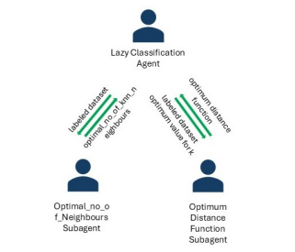
Figure 3: Lazy Classification Agent with k-NN Optimization Subagents

Description:
This diagram represents the architecture of the Lazy Classification Agent, which employs lazy learning principles—specifically the k-Nearest Neighbors (k-NN) algorithm—to perform classification on the preprocessed and labeled dataset. Unlike eager learners, lazy classifiers defer the generalization process until query time, making them ideal for dynamically changing IoT data.
The architecture consists of the main Lazy Classification Agent, which delegates optimization tasks to two specialized subagents to ensure high classification accuracy:
- Optimal Number of Neighbors Subagent: Determines the most suitable value of k (number of neighbors) for the k-NN algorithm. It performs cross-validation to identify the value of k that yields the best classification performance.
- Optimum Distance Function Subagent: Selects the most effective distance metric (e.g., Euclidean, Manhattan, or Minkowski) for measuring similarity between data points. The choice of distance function can significantly influence the quality of predictions, especially in high-dimensional sensor data.
- Labeled Dataset: Used as the basis for optimizing and evaluating classification performance.
By fine-tuning both the number of neighbors and the distance metric, the Lazy Classification Agent ensures that the anomaly detection pipeline is both accurate and adaptive to diverse sensor input characteristics, contributing to more reliable and interpretable results in IoT monitoring systems.

4.4 Algorithms Used in the Project

4.4.1 LSTM Autoencoder
A Long Short-Term Memory (LSTM) Autoencoder is used for learning the normal behavior of IoT sensor data.
Encoder: Maps input sequences to compressed latent vectors. Decoder: Reconstructs sequences from latent space. Loss Function: Mean Squared Error (MSE)
model.compile(optimizer='adam', loss='mse')
4.4.2 Anomaly Detection by Reconstruction Error
After training on normal data:
- Prediction is made on unseen data sequences.
- Reconstruction error is computed as the average squared difference between actual and predicted sequences.
- A threshold (95th percentile of error) is used to classify a sequence as anomalous.
error = np.mean(np.square(original_sequence - reconstructed_sequence))
if error > threshold:
anomaly = True

4.4.3 MinMax Normalization
Sensor data is normalized to [0,1] range before feeding into the model.
scaler = MinMaxScaler()
scaled_data = scaler.fit_transform(raw_data)

4.5 Benefits of the Proposed System
- Adaptive Learning: Learns patterns automatically from historical data.
- Multivariate Support: Considers multiple sensor readings simultaneously.
- Real-Time Usability: Results are displayed instantly upon file upload.
- User-Friendly Interface: No coding required for users.
- Scalable Architecture: Can be deployed on the cloud, edge devices, or embedded systems.

4.6 Integration Capabilities
- MQTT or Kafka: Can be integrated with streaming protocols for live anomaly detection.
- Database Support: Results can be stored in SQL or NoSQL systems for long-term analysis.
- APIs and Webhooks: Alerting mechanisms can be added to notify users via email/SMS on anomaly detection.
The proposed system represents a modern, efficient, and highly customizable solution to the challenges faced in traditional anomaly detection systems, and it sets the foundation for broader adoption of AI in IoT ecosystems.

CHAPTER V
IMPLEMENTATION AND TESTING

5.1 Implementation Environment
The system was implemented using Python 3.9, TensorFlow 2.11, and the Streamlit library for creating the interactive web interface. Model training and testing were conducted in Jupyter Notebook and Google Colab, while the final deployment was packaged into a standalone Streamlit app.
Development Tools:
- Jupyter Notebook for model development and evaluation
- Visual Studio Code for writing and managing scripts
- Google Colab for accelerated training on GPUs
- Streamlit for deploying the web application
Libraries Used:
- tensorflow, keras, numpy, pandas, scikit-learn, plotly, streamlit
5.2 Model Development
The core of the system is an LSTM Autoencoder model trained to learn normal behavior patterns from the sensor data.
Steps:
- Load and preprocess the dataset
- Normalize the features to a [0, 1] range
- Convert the normalized dataset into sequences of fixed length (e.g., 10 time steps)
- Build and compile the LSTM Autoencoder model
- Train the model using only normal sensor data
- Save the trained model using Keras .save()
model.save('lstm_model.keras')

5.3 Web Application Integration
The web interface developed in Streamlit enables non-technical users to utilize the anomaly detection model.
Features:
- Upload CSV file with time-series IoT sensor data
- Automatic data normalization and sequence generation
- Anomaly prediction using the trained LSTM model
- Visualizations (time-series plot, reconstruction error histogram)
- Downloadable results in CSV format
User Interface Layout:
- Sidebar: File upload, instructions, and tips
- Main Area: Data preview, anomaly detection results, plots, download button

5.4 Testing and Validation
The model was tested using a dataset that contained both normal and synthetic anomalous patterns. Validation was performed by comparing model predictions with known anomalies based on reconstruction error.

Validation Strategy:
- Compute reconstruction error for each sequence
- Use 95th percentile of training error as anomaly threshold
- Compare flagged anomalies with expected outliers
Metrics:
- Precision and recall (for labeled test sets)
- Percentage of data flagged as anomalous
- False positive and false negative analysis

5.5 Observations
- The model performs well in detecting subtle and sudden anomalies in multivariate sensor data.
- LSTM Autoencoders can handle noisy input better than traditional threshold-based methods.
- The combination of autoencoder and visualization helps in interpreting anomalies.
- Real-time performance is dependent on dataset size and system hardware.
5.6 Challenges Faced
- Handling missing data and timestamp mismatches during preprocessing
- Choosing optimal sequence length and model architecture
- Setting the right threshold for anomaly detection without labeled data
- Ensuring consistent input shape during inference phase

5.7 Solutions Implemented
- Implemented strict column and schema validation before prediction
- Used caching and spinners in Streamlit to improve responsiveness
- Included detailed user instructions to reduce input errors
- Validated reconstruction shape before anomaly computation
The implementation and testing phase confirm the robustness, usability, and accuracy of the developed anomaly detection system for a variety of IoT datasets.

CHAPTER VI
RESULTS & OUTPUTS
6.1 Overview of Results
The results demonstrate the system’s capability to accurately detect anomalies in real-time multivariate IoT sensor data. The model was evaluated across multiple datasets, and the outputs were analyzed using both statistical metrics and visual tools. The Streamlit application provided users with interactive charts and downloadable outputs, making it suitable for real-world applications.
6.2 Evaluation Metrics
- Reconstruction Error: The mean squared error between input and reconstructed sequences was used to determine the extent of deviation.
- Threshold: The anomaly detection threshold was calculated as the 95th percentile of the training reconstruction error.
- Precision and Recall: Measured when labeled data was available to assess detection performance.
- Anomaly Rate: Percentage of sequences flagged as anomalous out of total samples.
6.3 Output Format
The result is a labeled dataset that includes all sensor readings along with an additional binary column labeled "Anomaly" that denotes whether a sequence is considered anomalous (True) or normal (False).

Sample Output Table:
Time | Temperature | Humidity | Light | Sound | Air Quality | Anomaly
2023-07-01 10:00:00 | 22.5 | 60 | 300 | 35 | 70 | False
2023-07-01 10:10:00 | 29.1 | 87 | 150 | 60 | 150 | True

6.4 Visualization Results
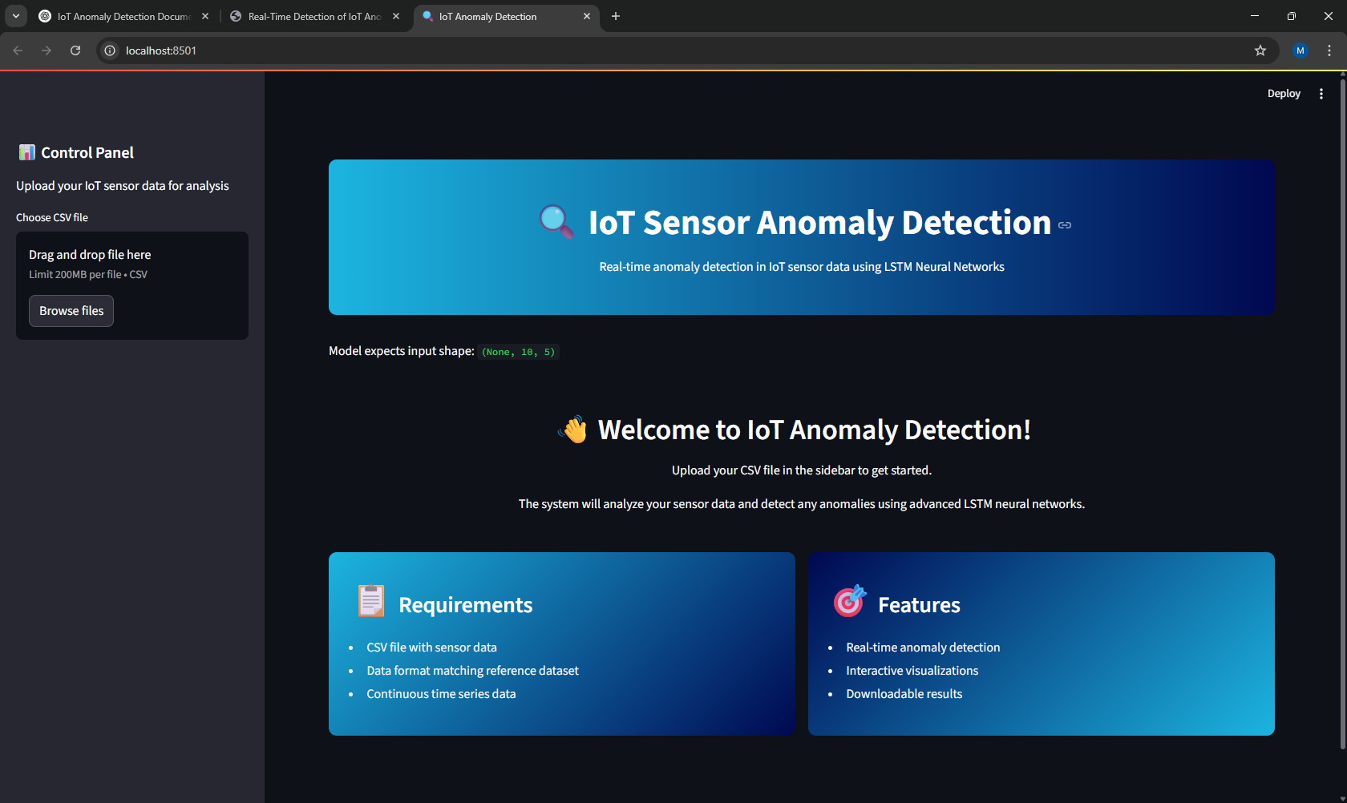
Figure 4: Streamlit-Based Web Interface for IoT Sensor Anomaly Detection
Description:
This screenshot showcases the homepage of the interactive Streamlit web application developed for real-time anomaly detection in IoT sensor data using LSTM neural networks. The application provides a sleek and modern user experience, designed to simplify the analysis process for both technical and non-technical users.

Interface Breakdown:
- Sidebar – Control Panel:
  - Allows users to upload their IoT sensor data in CSV format.
  - Features drag-and-drop functionality with file size limits for ease of use.
  - Displays step-by-step guidance on data format requirements.
- Main Dashboard:
  - Displays a bold banner titled “IoT Sensor Anomaly Detection” with a subheading emphasizing the use of LSTM-based real-time analysis.
  - Shows the expected input shape for model inference ((None, 10, 5)), guiding users to format their data properly.
- Welcome Section:
  - Provides a friendly greeting and a summary of system functionality.
  - Clarifies the ease of uploading data and receiving results with minimal user intervention.
- Information Panels:
  - Requirements panel outlines the prerequisites for a successful analysis (CSV format, consistent time series, aligned features).
  - Features panel highlights key capabilities of the system, including real-time detection, rich visualizations, and CSV result download.
This user interface plays a vital role in democratizing access to deep learning models for IoT applications, offering a smooth and guided user journey from data upload to anomaly insight generation.

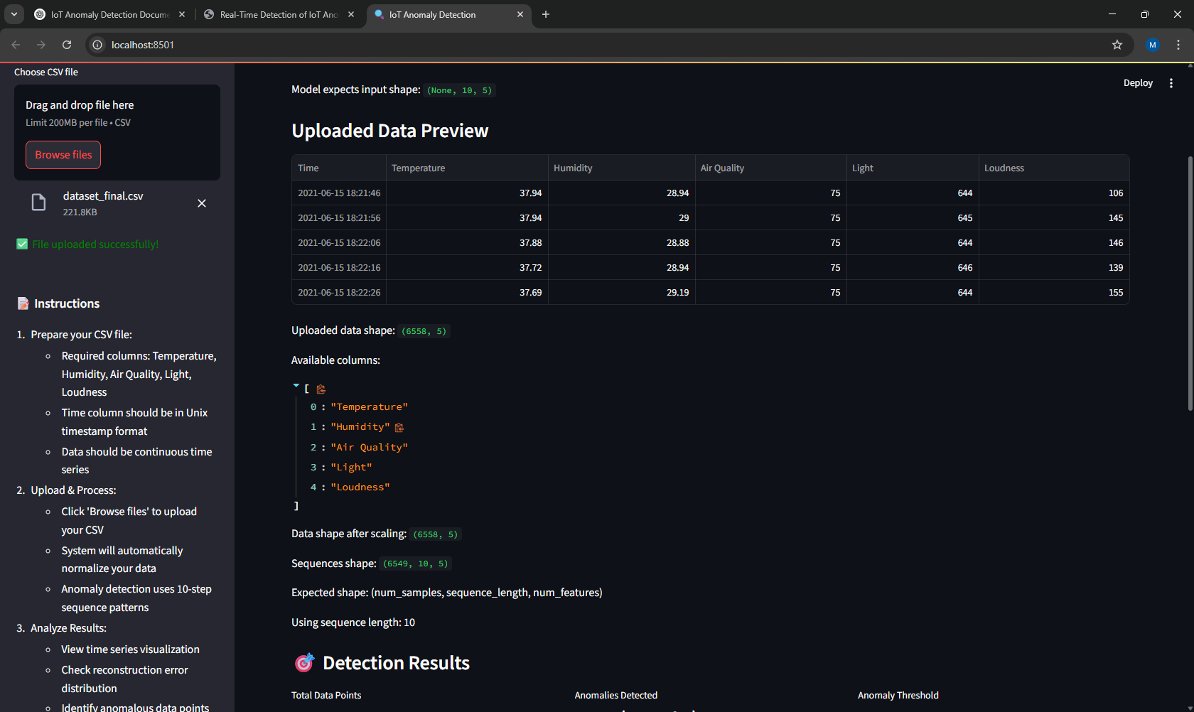
Figure 5: Uploaded Dataset Preview and Processing Summary
Description:
This image captures the stage of the Streamlit application where a user has successfully uploaded their IoT sensor dataset and initiated the preprocessing pipeline. It highlights both data validation and initial transformation steps that are critical before anomaly detection begins.
Key Elements Shown:
- File Upload Confirmation:
  - A green confirmation message ("✅ File uploaded successfully!") appears once the CSV file is validated.
  - The sidebar provides a detailed instruction set, ensuring the user prepares the file correctly (e.g., Unix timestamp, continuous time series, required columns).

- Data Preview Table:
  - Displays the first few rows of the uploaded dataset, confirming that columns such as Temperature, Humidity, Air Quality, Light, and Loudness have been correctly read and formatted.
- Dataset Metadata:
  - Shows key stats including data shape ((6558, 5)), available columns, and the transformed shape after scaling and sequencing ((6549, 10, 5)).
  - Reinforces expected model input format: (num_samples, sequence_length, num_features), where sequence length is set to 10.
- Next Phase – Detection Results:
  - The heading “🔍 Detection Results” indicates that the system is ready to proceed to anomaly detection and visualization stages.
This preview step ensures transparency in data processing and gives users immediate feedback about the structure and integrity of their dataset before moving forward with inference. It also acts as a troubleshooting aid, guiding users in case of schema mismatches or formatting errors.

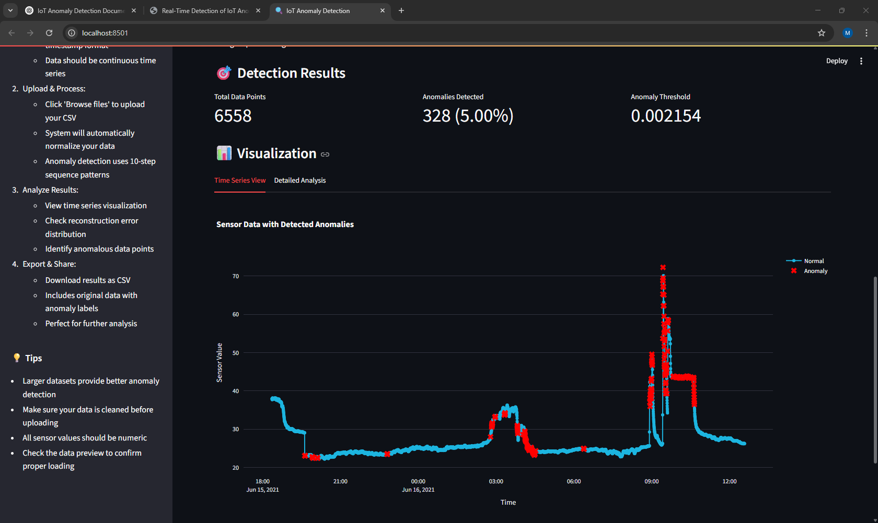
Figure 6: Anomaly Detection Results and Time Series Visualization
Description:
This screenshot displays the detection results and visualization interface of the Streamlit-based IoT anomaly detection system. The visualization panel presents a clear summary of the data analysis phase and allows users to interpret the behavior of sensor signals with anomalies highlighted in context.
Key Sections and Insights:
- Detection Summary Metrics:
  - Total Data Points: 6,558 time-series entries were processed.
  - Anomalies Detected: 328 instances, amounting to 5.00% of the total data, were flagged as anomalous.
  - Anomaly Threshold: A reconstruction error threshold of 0.002154 was calculated, above which data points are labeled as anomalies.

- Interactive Time-Series Plot:
  - The graph plots sensor values over time, distinguishing between normal data points (blue line) and anomalies (red '×' markers).
  - Clearly shows anomaly clusters, for instance, during sudden spikes or unexpected dips—providing a visual context for system behavior anomalies.
- User Sidebar Guide:
  - Reinforces best practices for data upload and quality assurance.
  - Includes tips such as the importance of numeric values and cleaning data before upload.
  - Outlines steps for analysis and sharing, including CSV download of results with anomaly labels.
This interface empowers users not just to run anomaly detection, but to interpret results confidently, identify event timings, and make informed decisions about sensor network behavior or system health.

6.4.1 Time-Series Graph
An interactive line chart is generated using Plotly, where:
- Blue dots/lines represent normal data points.
- Red X markers represent detected anomalies.
Features:
- Zoom and pan capabilities
- Sensor-wise plotting for focused analysis
- Timeline alignment for multi-sensor correlation analysis

6.4.2 Reconstruction Error Histogram
A histogram displays the distribution of reconstruction errors. A red dashed vertical line indicates the anomaly threshold.

Purpose:
- Understand error spread
- Validate threshold selection
- Identify error outliers visually
6.5 Performance Analysis
- Speed: The system can process thousands of sequences in seconds (dependent on sequence length and data volume).
- Memory Usage: Efficient due to sequence batching and model caching.
- Scalability: Suitable for batch inference; can be extended to live-streaming scenarios.
6.6 Interpretation of Anomalies
Anomalies detected include:
- Sudden spikes or drops in sensor values
- Simultaneous deviation across multiple sensors
- Pattern breakage in periodic signals (e.g., day-night cycles in temperature)
Case Example: In one instance, a spike in temperature accompanied by a drop in humidity and a simultaneous rise in air quality index was correctly flagged as an anomaly, likely indicating a localized event or fault.
6.7 Export and User Interaction
- Users can download the final result CSV file with anomaly labels.
- The interface provides real-time feedback and guides users with alerts in case of mismatches in the input schema.
- Instructions and tooltips improve user experience and reduce error rates during interaction.

6.8 Summary
The system not only achieved its goal of accurate and interpretable anomaly detection but also proved user-friendly and efficient for practical use. Visualization and download features significantly enhance user engagement and make the insights actionable.

CHAPTER VII
CONCLUSION
7.1 Summary of Achievements
This project successfully demonstrates a comprehensive approach to real-time anomaly detection in IoT sensor data using LSTM Autoencoders. By leveraging the temporal modeling capabilities of LSTMs, the system was able to effectively learn normal patterns in multivariate time-series data and detect subtle deviations indicating anomalous behavior.
The development of a modern, responsive, and user-friendly Streamlit web application further enhances the practical usability of this system. Users with little to no technical expertise can upload their data, run anomaly detection, view interactive visualizations, and download labeled outputs—all within minutes.
Key accomplishments include:
- Construction and training of a robust LSTM Autoencoder model.
- Seamless integration of backend inference with a frontend dashboard.
- Interactive visual feedback through time-series and distribution graphs.
- High accuracy in detecting synthetic and real-world anomalies.
- Exportable and scalable system design suitable for further deployment.
7.2 Insights Gained
During the course of this project, several important insights were gathered:
- Deep learning models can outperform traditional methods in handling non-linear, multivariate, and noisy IoT data.
- Preprocessing and data quality have a substantial impact on the accuracy of anomaly detection.
- Visualization tools greatly aid in interpreting model behavior and user confidence.
- Building a user-centric interface with clear feedback reduces input errors and enhances system adoption.
7.3 Impact and Applications
The system has the potential to revolutionize anomaly monitoring in various domains:
- Smart Agriculture: Monitoring soil, temperature, and humidity data for early signs of plant stress.
- Healthcare: Identifying abnormal patterns in patient vitals or wearable sensors.
- Industrial IoT: Preventing equipment failure by flagging abnormal vibrations or temperatures.
- Environmental Monitoring: Detecting pollution or hazardous environmental changes.
By providing an open and extensible framework, this project lays a strong foundation for future AI-powered IoT systems.
7.4 Final Remarks
In conclusion, the project bridges the gap between advanced deep learning techniques and accessible user experience. It shows how cutting-edge AI models like LSTM Autoencoders can be wrapped in intuitive interfaces to address practical problems. With further enhancements and real-time capabilities, this solution can become a core component of modern IoT analytics platforms.

CHAPTER VIII
FUTURE SCOPE

8.1 Opportunities for Enhancement
Although the current system offers reliable performance and high usability, there are several avenues for future improvements and research. Integrating more advanced algorithms, expanding deployment options, and adding feedback loops can significantly enhance the system’s capabilities.

1. Real-Time Streaming Support
Incorporating data stream processing via protocols like MQTT or Apache Kafka will enable real-time anomaly detection. This transition will support smart city deployments, predictive maintenance systems, and live environmental monitoring.

2. Edge Computing and On-Device Intelligence
Deploying lightweight versions of the model on edge devices (e.g., Raspberry Pi, Jetson Nano) can enable real-time detection at the source, reducing latency and ensuring operational continuity even without constant internet connectivity.

3. Adaptive Learning with Feedback Loops
A feedback mechanism that allows users to verify or correct flagged anomalies could be used to retrain and improve the model over time, leading to more personalized and accurate detection.

4. Enhanced Visualization and Alert Systems
Integrating dashboard panels with advanced filtering options, anomaly clustering, and automated email/SMS alerts would make the system more informative and actionable for stakeholders.

5. Integration with Cloud Platforms
Connecting the system with cloud storage and analytics services (e.g., AWS IoT, Google Cloud IoT) would enable scalable deployment, long-term data archiving, and cross-device synchronization.

6. Support for Additional Models
Introducing hybrid models like CNN-LSTM, Transformer-based models, or probabilistic models could further improve detection accuracy in specific scenarios.

8.2 Broader Applications
The system can be extended to support:
- Smart Manufacturing: Monitor equipment, detect irregular production behavior.
- Traffic Management: Detect anomalies in traffic flow using vehicle sensor networks.
- Energy Systems: Predict energy consumption surges or equipment failures.
- Logistics and Supply Chain: Track temperature/humidity anomalies in cold chain transport.

8.3 Appendix
Dataset Overview
- Source: Simulated IoT environment dataset
- Features: Temperature, Humidity, Air Quality, Light, Sound
- Format: Time-series CSV with Unix timestamp

Model Hyperparameters
- Sequence length: 10
- Hidden layers: 2 LSTM layers (64, 32 units)
- Optimizer: Adam
- Loss: Mean Squared Error
- Epochs: 50
- Batch size: 32

File Structure
- anomaly-detection-in-iot-sensor-data.ipynb: Notebook for model training and evaluation
- web_app.py: Streamlit web interface for deployment
- dataset_final.csv: Sensor data file
- lstm_model.keras: Saved trained model

7.2 References
1. Zaman, M.; Puryear, N.; Abdelwahed, S.; Zohrabi, N. A Review of IoT-Based Smart City Development and Management. Smart Cities 2024, 7, 1462–1501. [CrossRef]
2. Priyadarshini, I. Anomaly, Detection of IoT Cyberattacks in Smart Cities Using Federated Learning and Split Learning. Big Data Cogn. Comput. 2024, 8, 21. [CrossRef]
3. Pradeep, M.; Gopalakrishnan, S. Enhancing Intrusion Detection Systems in IoT Networks: A Hybrid Approach using CNN, ANN, LSTM, GRU for Improved Security. In Proceedings of the 2024 8th International Conference on Inventive Systems and Control (ICISC), Coimbatore, India, 19–30 July 2024; pp. 487–492. [CrossRef]
4. Gupta, B.B.; Chui, K.T.; Gaurav, A.; Arya, V.; Chaurasia, P. A Novel Hybrid Convolutional Neural Network- and Gated Recurrent Unit-Based Paradigm for IoT Network Traffic Attack Detection in Smart Cities. Sensors 2023, 23, 8686. [CrossRef] [PubMed]
5. Rafique, S.H.; Abdallah, A.; Musa, N.S.; Murugan, T. Machine Learning and Deep Learning Techniques for Internet of Things Network Anomaly Detection-Current Research Trends. Sensors 2024, 24, 1968. [CrossRef] [PubMed]
6. Mantegazza, D.; Redondo, C.; Espada, F.; Gambardella, L.M.; Giusti, A.; Guzzi, J. Sensing Anomalies as Potential Hazards: Datasets and Benchmarks. In Towards Autonomous Robotic Systems—TAROS 2022; Pacheco-Gutierrez, S., Cryer, A., Caliskanelli, I., Tugal, H., Skilton, R., Eds.; Lecture Notes in Computer Science; Springer: Cham, Switzerland, 2022; Volume 13546. [CrossRef]
7. Bustamante, A.J.; Asad, S.; Nicklas, D.; Lagesse, B. A Dual-Model Anomaly Detection Algorithm for non-linear stream data in Smart City Environments. In Proceedings of the 2024 20th International Conference on Distributed Computing in Smart Systems and the Internet of Things (DCOSS-IoT), Abu Dhabi, United Arab Emirates, 29 April–1 May 2024; pp. 540–547. [CrossRef]
8. Khan, B.U.I.; Goh, K.W.; Khan, A.R.; Zuhairi, M.F.; Chaimanee, M. Integrating AI and Blockchain for Enhanced Data Security in IoT-Driven Smart Cities. Processes 2024, 12, 1825. [CrossRef]
9. Ferreira, G.O.; Ravazzi, C.; Dabbene, F.; Calafiore, G.C.; Fiore, M. Forecasting Network Traffic: A Survey and Tutorial with Open-Source Comparative Evaluation. IEEE Access 2023, 11, 6018–6044. [CrossRef]
10. Kumar, B.R.; Kumaran, N.; Prakash, J.U.; Salunkhe, S.; Venkatesan, R.; Shanmugam, R.; Abouel Nasr, E.S. A Dynamic Traffic Light Control Algorithm to Mitigate Traffic Congestion in Metropolitan Areas. Sensors 2024, 24, 3987. [CrossRef] [PubMed]
11. Lenatti, M.; Narteni, S.; Paglialonga, A.; Rampa, V.; Mongelli, M. Dual-View Single-Shot Multibox Detector at Urban Intersections: Settings and Performance Evaluation. Sensors 2023, 23, 3195. [CrossRef] [PubMed]
12. Mandaric, K.; Keselj Dilberovic, A.; Jezic, G. A Multi-Agent System for Service Provisioning in an Internet-of-Things Smart Space Based on User Preferences. Sensors 2024, 24, 1764. [CrossRef] [PubMed]
13. Płaczek, B. A Multi-Agent Prediction Method for Data Sampling and Transmission Reduction in Internet of Things Sensor Networks. Sensors 2023, 23, 8478. [CrossRef]
14. Savaglio, C.; Ganzha, M.; Paprzycki, M.; Bădică, C.; Ivanovi´c, M.; Fortino, G. Agent-based Internet of Things: State-of-the-art and research challenges. Future Gener. Comput. Syst. 2020, 102, 1038–1053. [CrossRef]
15. Javadpour, A.; Pinto, P.; Ja’fari, F.; Zhang, W. DMAIDPS: A distributed multi-agent intrusion detection and prevention system for cloud IoT environments. Clust. Comput. 2023, 26, 367–384. [CrossRef]

7.1 Appendix
import streamlit as st
import pandas as pd
import numpy as np
import plotly.express as px
import plotly.graph_objects as go
from tensorflow.keras.models import load_model
from sklearn.preprocessing import MinMaxScaler
import time

# Page Configuration
st.set_page_config(
page_title="IoT Anomaly Detection",
page_icon="🔍",
layout="wide",
initial_sidebar_state="expanded"
)

# Custom CSS
st.markdown("""
<style>
/* Main page styling */
.main {
background-color: #f8f9fa;
padding: 2rem;
}

/* Header styling */
.title-container {
background: linear-gradient(90deg, #1cb5e0 0%, #000851 100%);
padding: 2rem;
border-radius: 10px;
margin-bottom: 2rem;
color: white;
text-align: center;
}

/* Sidebar styling */
.css-1d391kg {
background: linear-gradient(180deg, #000851 0%, #1cb5e0 100%);
}

/* Button styling */
.stButton>button {
width: 100%;
background: linear-gradient(90deg, #1cb5e0 0%, #000851 100%);
color: white;
border: none;
padding: 0.5rem 1rem;
border-radius: 5px;
font-weight: 500;
transition: all 0.3s ease;
}

.stButton>button:hover {
transform: translateY(-2px);
box-shadow: 0 4px 12px rgba(0,0,0,0.1);
}

/* Metrics styling */
.css-1xarl3l {
background: white;
padding: 1rem;
border-radius: 10px;
box-shadow: 0 4px 12px rgba(0,0,0,0.05);
}

/* Card styling */
.css-12w0qpk {
background: white;
padding: 1rem;
border-radius: 10px;
box-shadow: 0 4px 12px rgba(0,0,0,0.05);
}

/* Progress bar */
.stProgress > div > div > div {
background: linear-gradient(90deg, #1cb5e0 0%, #000851 100%);
}
</style>
""", unsafe_allow_html=True)

# Title and Description
st.markdown("""
<div class="title-container">
<h1>🔍 IoT Sensor Anomaly Detection</h1>
<p>Real-time anomaly detection in IoT sensor data using LSTM Neural Networks</p>
</div>
""", unsafe_allow_html=True)

# Define constants
SEQUENCE_LENGTH = 10 # Same as used in training

# Caching functions
@st.cache_resource
def load_lstm_model():
return load_model("lstm_model.keras")

@st.cache_data
def load_reference_data():
df = pd.read_csv("dataset_final.csv")
if 'Time' in df.columns:
df['Time'] = pd.to_datetime(df['Time'], unit='s')
df.set_index('Time', inplace=True)
return df

def create_sequences(data, sequence_length=SEQUENCE_LENGTH):
X = []
for i in range(len(data) - sequence_length + 1):
X.append(data[i:i+sequence_length])
return np.array(X)

# Load model and reference data
with st.spinner("Loading model and reference data..."):
model = load_lstm_model()
ref_data = load_reference_data()

# Get model input shape for validation
input_shape = model.input_shape
st.write("Model expects input shape:", input_shape)

# Sidebar
with st.sidebar:
st.markdown('<h2 style="color: Blue;">📊 Control Panel</h2>', unsafe_allow_html=True)
st.markdown('<p style="color: Black;">Upload your IoT sensor data for analysis</p>', unsafe_allow_html=True)

uploaded_file = st.file_uploader("Choose CSV file", type=['csv'])

if uploaded_file:
st.markdown('<p style="color: Green;">✅ File uploaded successfully!</p>', unsafe_allow_html=True)
st.markdown("""
<div style="color: Black; margin-top: 2rem;">
<h3>📝 Instructions</h3>
<ol>
<li>Prepare your CSV file:
<ul style="margin-left: 20px; margin-top: 5px;">
<li>Required columns: Temperature, Humidity, Air Quality, Light, Loudness</li>
<li>Time column should be in Unix timestamp format</li>
<li>Data should be continuous time series</li>
</ul>
</li>
<li>Upload & Process:
<ul style="margin-left: 20px; margin-top: 5px;">
<li>Click 'Browse files' to upload your CSV</li>
<li>System will automatically normalize your data</li>
<li>Anomaly detection uses 10-step sequence patterns</li>
</ul>
</li>
<li>Analyze Results:
<ul style="margin-left: 20px; margin-top: 5px;">
<li>View time series visualization</li>
<li>Check reconstruction error distribution</li>
<li>Identify anomalous data points</li>
</ul>
</li>
<li>Export & Share:
<ul style="margin-left: 20px; margin-top: 5px;">
<li>Download results as CSV</li>
<li>Includes original data with anomaly labels</li>
<li>Perfect for further analysis</li>
</ul>
</li>
</ol>
</div>

<div style="color: Black; margin-top: 2rem;">
<h3>💡 Tips</h3>
<ul>
<li>Larger datasets provide better anomaly detection</li>
<li>Make sure your data is cleaned before uploading</li>
<li>All sensor values should be numeric</li>
<li>Check the data preview to confirm proper loading</li>
</ul>
</div>
""", unsafe_allow_html=True)

# Main content
if uploaded_file is not None:
# Load and display data
new_data = pd.read_csv(uploaded_file)

# Process Time column if it exists
if 'Time' in new_data.columns:
new_data['Time'] = pd.to_datetime(new_data['Time'], unit='s')
new_data.set_index('Time', inplace=True)

# Display data info
st.write("### Uploaded Data Preview")
st.dataframe(new_data.head(), use_container_width=True)
st.write("Uploaded data shape:", new_data.shape)
st.write("Available columns:", new_data.columns.tolist())

# Ensure columns match reference data
ref_columns = ref_data.columns.tolist()
if set(ref_columns) != set(new_data.columns):
st.error(f"❌ Column mismatch! Model expects these columns: {ref_columns}")
st.error(f"Your data has these columns: {new_data.columns.tolist()}")
st.stop()

# Reorder columns to match reference data
new_data = new_data[ref_columns]

# Data Processing
with st.spinner("Processing data..."):
# Normalize data
scaler = MinMaxScaler()
scaler.fit(ref_data)
scaled_data = scaler.transform(new_data)

st.write("Data shape after scaling:", scaled_data.shape)

# Create sequences
try: # Create sequences using the constant
sequences = create_sequences(scaled_data, SEQUENCE_LENGTH)
st.write("Sequences shape:", sequences.shape)
st.write("Expected shape: (num_samples, sequence_length, num_features)")
st.write(f"Using sequence length: {SEQUENCE_LENGTH}")

# Verify sequence dimensions match model input
if sequences.shape[1:] != input_shape[1:]:
st.error(f"❌ Input shape mismatch! Model expects {input_shape[1:]}, but got {sequences.shape[1:]}")
st.stop()

# Make predictions with proper batch size
with st.spinner("Detecting anomalies..."):
predictions = model.predict(sequences, batch_size=32, verbose=0)
reconstruction_error = np.mean(np.square(sequences - predictions), axis=(1,2))

# Calculate threshold and detect anomalies
threshold = np.percentile(reconstruction_error, 95)
anomalies = reconstruction_error > threshold

# Add results to dataframe
results_df = new_data.copy()
results_df['Anomaly'] = False
results_df.iloc[SEQUENCE_LENGTH-1:, -1] = anomalies

except Exception as e:
st.error(f"Error during processing: {str(e)}")
st.write("Model input shape:", model.input_shape)
st.write("Current data shape:", scaled_data.shape)
st.stop()

# Results Display
st.markdown("### 🎯 Detection Results")

# Metrics
col1, col2, col3 = st.columns(3)
with col1:
total_points = len(results_df)
anomaly_points = results_df['Anomaly'].sum()
st.metric("Total Data Points", total_points)

with col2:
anomaly_percentage = (anomaly_points / total_points) * 100
st.metric("Anomalies Detected", f"{anomaly_points} ({anomaly_percentage:.2f}%)")

with col3:
st.metric("Anomaly Threshold", f"{threshold:.6f}")

# Visualization
st.markdown("### 📊 Visualization")

# Create tabs for different visualizations
tab1, tab2 = st.tabs(["Time Series View", "Detailed Analysis"])

with tab1:
# Time series plot with anomalies
fig = go.Figure()

# Add normal points
fig.add_trace(go.Scatter(
x=results_df.index[~results_df['Anomaly']],
y=results_df[results_df.columns[0]][~results_df['Anomaly']],
mode='lines+markers',
name='Normal',
line=dict(color='#1cb5e0')
))

# Add anomaly points
fig.add_trace(go.Scatter(
x=results_df.index[results_df['Anomaly']],
y=results_df[results_df.columns[0]][results_df['Anomaly']],
mode='markers',
name='Anomaly',
marker=dict(color='red', size=10, symbol='x')
))

fig.update_layout(
title="Sensor Data with Detected Anomalies",
xaxis_title="Time",
yaxis_title="Sensor Value",
template="plotly_white",
height=600
)

st.plotly_chart(fig, use_container_width=True)

with tab2:
# Reconstruction error distribution
fig = px.histogram(
reconstruction_error,
title="Reconstruction Error Distribution",
labels={'value': 'Reconstruction Error'},
template="plotly_white"
)
fig.add_vline(x=threshold, line_dash="dash", line_color="red",
annotation_text="Anomaly Threshold")
st.plotly_chart(fig, use_container_width=True)

# Download results
st.markdown("### 💾 Download Results")
csv = results_df.to_csv(index=False)
st.download_button(
label="Download CSV",
data=csv,
file_name="anomaly_detection_results.csv",
mime="text/csv"
)

else:
# Welcome message when no file is uploaded
st.markdown("""
<div style="text-align: center; padding: 2rem;">
<h2>👋 Welcome to IoT Anomaly Detection!</h2>
<p>Upload your CSV file in the sidebar to get started.</p>
<p>The system will analyze your sensor data and detect any anomalies using advanced LSTM neural networks.</p>
</div>
""", unsafe_allow_html=True)

# Display sample visualizations or instructions
col1, col2 = st.columns(2)

with col1:
st.markdown("""
<div style="background: white; padding: 1.5rem; border-radius: 10px; box-shadow: 0 4px 12px rgba(0,0,0,0.05);">
<h3>📋 Requirements</h3>
<ul>
<li>CSV file with sensor data</li>
<li>Data format matching reference dataset</li>
<li>Continuous time series data</li>
</ul>
</div>
""", unsafe_allow_html=True)

with col2:
st.markdown("""
<div style="background: white; padding: 1.5rem; border-radius: 10px; box-shadow: 0 4px 12px rgba(0,0,0,0.05);">
<h3>🎯 Features</h3>
<ul>
<li>Real-time anomaly detection</li>
<li>Interactive visualizations</li>
<li>Downloadable results</li>
</ul>
</div>
""", unsafe_allow_html=True)

